p

FAIR ISLE
Detect and Rephrase non-inclusive texts
Sommario
Abstract 2
Technical Architecture and Operation 4
Analysis pipeline 4
The Dataset and its Evolution 4
The initial dataset: structure and cleaning 4
Data augmentation and Italian dataset 5
English dataset 5
Multilingual dataset 5
Implementation of AI Models for the English Language 5
The Bias Classifier 5
Inclusive Rewriter 6
Model Integration 7
Implementation of AI Models for the Italian Language 7
Bias Classifier 7
Inclusive Rewriter 8
The Initial Challenge and the Change of Strategy 8
The Importance of the Extended Dataset 9
Implementation of AI Models for Multilingual 9
Unification and Expansion of the Dataset 10
Multilingual Classifier 10
The Multilingual Rewriter 11
Quantitative Performance Analysis 12
Computation Methodology 12
Classifier Results 12
Rewriter Results 13
Comparative Analysis and Final Considerations 14
Higher quality of specialist models 14
User Interface and User Experience (UX) 14
The prototyping phase 14
Il Redesign 15
Active Feedback Loop 16
Essential references 17


Professor: Prof. Semeraro, Prof. Musto
Tutor: Prof. Basile, Prof. Siciliani
Exam: Semantics in Intelligent Information Access
Project: FAIR ISLE - Detect and Rephrase non-inclusive texts
GitHub Link: https://github.com/Roberto1512/SIIA
Students:
- Lauriola Michele
- Selvaggi Roberto Pio

Abstract
FAIR ISLE is a webapp that identifies non-inclusive language and proposes inclusive rewrites in Italian and English. The project combines a bias classifier with a seq2seq rewriter trained on curated datasets expanded through data augmentation, under psychological supervision.
The pipeline integrates a user feedback cycle for continuous improvement and defines a multi-level evolutionary roadmap to increase contextual sensitivity. Quantitative results indicate high performance in monolingual classification and a rewriting quality consistent with the adopted automatic metrics.
The context: Language and social perception
Language is not merely a tool to describe reality, but a means that actively contributes to shaping it, influencing attitudes, behaviors, and social norms.
As highlighted by the European Institute for Gender Equality (EIGE), words matter in defining our worldview: the predominant use of masculine terms for general references reflects and reinforces assumptions about gender roles, contributing to the invisibility of women in the public sphere.
Inclusive or gender-sensitive language, therefore, is not a stylistic whim, but a strategy to make differences and needs visible, reduce unconscious stereotypes, and promote equal opportunities.
Regulations and Reference Guidelines
The development of tools for linguistic inclusivity fits within a well-defined regulatory and cultural framework, both internationally and nationally.
At the international level, UN Women and the European Union promote guidelines to avoid discriminatory formulations and encourage neutral or doubly marked terms when relevant.
The American Psychological Association (APA) insists on specificity and neutrality in describing people, avoiding demeaning labels and unnecessary binaries. In Italy, primary references are the MIUR Guidelines (2018) and UNI standards for gender equality in administrative and educational language.
Current linguistic challenges
From the state of the art, three classes of problems emerge that a rewriting system must address:
- Stereotypes: rigid attribution of roles or abilities based on gender (e.g., care professions associated with women).
- Invisibility and omission: use of the overextended masculine or generic terms that erase female presence.
- Subordination: use of suffixes or asymmetrical forms of address that imply lesser value or infantilization.).
Goal of the FAIR ISLE tool
FAIR ISLE was created with the objective of combining linguistic accuracy, computational efficiency, and social usefulness.
• Automatically detect non-inclusive expressions in short and long texts.
• Generate inclusive rewrites that preserve meaning, tone, and communicative intent.
• Support Italian and English, with experimentation of a multilingual version.
• Integrate a feedback loop to collect human corrections.
• Ensure response times suitable for an interactive webapp.
Implemented Linguistic Methodology
Rewriting is not limited to grammatical corrections, but applies strategies that reduce bias while maintaining text readability.
• Double inflection: explicit mention of both genders (e.g., “tutte e tutti”).
• Paraphrasing: replacement of the overextended masculine with neutral forms (e.g., “personale”, “chi ha interesse”).
• Impersonal or passive forms: shifting the focus to the action or the object to remove gender reference.
In tests, double inflection increased visibility but can weigh down the text; for this reason, paraphrases and impersonal forms are preferred when they do not compromise clarity and naturalness.

Technical Architecture and Operation
The system is organized as a modular pipeline composed of classification and rewriting, with confidence handling and structured output.
However, during the development phase, the limits of this “flat” approach were identified: it does not always capture ambiguous expressions and lacks contextual memory.
The backend is implemented in Flask and uses Hugging Face Transformers pipelines with models saved locally in models/.

Analysis pipeline
- Segmentation of text into sentences.
- Classification of bias with associated probability.
- Return of label, score and rewrite proposal to the interface.

The Dataset and its Evolution
The beating heart of the FAIR ISLE project is represented by the knowledge base on which the model was trained. The quality and variety of the data are in fact decisive to ensure that the system not only recognizes explicit forms of discrimination, but also captures more subtle nuances of non-inclusive language.
A fundamental and cross-cutting aspect of all the work on data was rigorous scientific supervision: every single operation carried out on the datasets, from initial cleaning to the massive generation of new examples, was supervised and received formal approval from the team psychologist. This step ensured that linguistic corrections were not only grammatically correct, but also psychologically and emotionally appropriate, avoiding the risk of replacing one bias with another or using paternalistic language.

The initial dataset: structure and cleaning
The starting point was the file dataset_chatgpt_001.xlsx, an initial corpus composed of 449 examples. This dataset was built by collecting sentences representative of different categories of bias: gender stereotypes (e.g., related to professions or behaviors), discrimination based on age, ethnicity, sexual orientation, and disabilities.
Each entry in the original dataset was structured into multiple fields: the “non-inclusive sentence”, the “inclusive sentence” (the proposed correction), a possible alternative variant, the identified bias type, and a validation field. Before proceeding with use, a rigorous cleaning operation was carried out. Through a dedicated script, only positively validated rows were selected, discarding doubtful or non-relevant examples. In this phase, the psychologist’s review was decisive in choosing, among the various rewrite alternatives, those that showed the greatest sensitivity and empathy toward the represented categories. The result was a “clean” data core, free of duplicates and semantically flawless.

Data augmentation and Italian dataset
To increase variety, data augmentation was performed with Google Gemini, generating new variations consistent with the original corrections. The first extended dataset (dataset_completo) reached 5,367 pairs. Subsequently, the Italian corpus was expanded further up to dataset_it.json (16,672 pairs), used for fine-tuning the IT5 rewriter.

English dataset
In parallel with work on the Italian language, a specific dataset for English was developed, again leveraging the generative capabilities of Google Gemini. The goal was not a simple literal translation of the Italian dataset—which would have risked importing non-relevant cultural biases—but the creation of a native corpus for the anglophone context. Google Gemini was specifically instructed on international guidelines (such as those of the UN or the APA) to generate from scratch 4,980 sentence pairs.
The model produced examples addressing the same macro-topics (gender bias, ageism, ableism) but expressed according to English sensitivities and linguistic constructions, such as the use of “singular they” or the deconstruction of specific stereotypes of Anglo-Saxon culture.
The psychologist’s final approval of this set certified that the original inclusive and empathetic intent had been preserved and correctly transferred into English as well, ensuring that FAIR ISLE can operate effectively and respectfully in a multicultural context.

Multilingual dataset
The Italian and English datasets were unified into dataset_multi.json (21,653 pairs), normalizing the JSON lines format with the fields ‘non_inclusiva’ and ‘inclusiva’. Mixing languages forced the models to generalize the concept of bias beyond specific linguistic patterns.

Implementation of AI Models for the English Language
The FAIR ISLE system architecture for English mirrors the dual structure already validated for Italian, composed of two distinct but complementary entities: a Classifier, responsible for detecting the presence of bias, and a Rewriter, responsible for transforming the text into an inclusive form.
The entire development, training, and validation process was conducted using the Google Colab environment. This choice made it possible to exploit cloud GPU computing resources, essential for fine-tuning Transformer-based models, while ensuring flexibility and code reproducibility through Jupyter Notebooks.

The Bias Classifier
The first component of the pipeline is the classifier, whose task is to analyze the input sentence and determine whether it contains non-inclusive elements. This step is crucial to activate the rewriting module only when strictly necessary, preserving the original text when it is already correct.
Model choice: DistilBERT For this task, the distilbert-base-uncased model was selected. The choice was driven by a precise balance between performance and lightness: DistilBERT is a “distilled” version of the well-known BERT, retaining over 95% of the original model’s performance while being 40% smaller and 60% faster.
- Motivation: Since this is a binary classification task (Inclusive / Non-Inclusive) or multiclass (identification of the bias type), the computational power of larger models would have been redundant. DistilBERT guarantees minimal inference latency, a fundamental aspect for a webapp that must respond in real time.
Data preparation and training The data from the dataset was processed to adapt them to the format required by the model:
- Labeling: Target labels were assigned (0 for inclusive text, 1 for non-inclusive).
- Tokenization: Text was converted into numeric tokens using DistilBERT’s native tokenizer (AutoTokenizer), applying truncation to handle variable lengths.
- Training and hyperparameters: The model was trained (fine-tuned) using Hugging Face’s Trainer class, configuring hyperparameters to maximize stability and convergence. Specifically, training was set to 3 epochs, with a conservative learning rate of 2e-5 and a batch size of 16 for training (32 for evaluation), balancing speed and VRAM usage. To ensure robustness and prevent overfitting, a weight decay of 0.01 was applied.
- Evaluation and saving: The evaluation strategy included a full check at the end of each epoch. The system was configured to automatically save only the best model, using the F1-Score as the reference metric, considered more reliable than simple Accuracy in semantic classification contexts. In addition, mixed precision (FP16) was enabled to speed up GPU computations.

Inclusive Rewriter
Once the classifier has labeled a sentence as “non-inclusive”, the second model comes into play. Its goal is to generate a new version of the sentence that removes bias while preserving the original semantic meaning.
Model choice: Google FLAN-T5 For rewriting (a Seq2Seq or Text-to-Text task), the google/flan-t5-base model was chosen.
- Motivation: T5 (Text-to-Text Transfer Transformer) is an architecture specifically designed for tasks where both input and output are text strings. The “FLAN” variant is particularly suitable because it underwent instruction tuning, which dramatically improves the model’s ability to understand complex commands and nuanced contexts, such as the request to “make this sentence inclusive without changing its meaning”. The “base” version offers the right compromise between generative quality and required computational resources.
Data preparation and training the training process for the rewriter followed specific steps:
- Preprocessing e Prompting: Sentence pairs (Input: Biased sentence -> Target: Inclusive sentence) were tokenized with a maximum length (max_length) of 128 tokens, sufficient to cover most common sentences. A fundamental technical detail is the use of a prefix prompt: each input sentence was preceded by the instruction string “Rewrite the sentence using inclusive language:”. This guides the model toward the specific task from the very first token.
- Fine-Tuning: The model was trained for 3 epochs using a learning rate of 5e-5 and a warmup ratio of 5% to stabilize the early learning phase. To manage GPU memory limits while maintaining stable training, a batch size of 4 was used with gradient accumulation steps set to 2, effectively simulating a larger batch.
- Valutazione (Approccio Multi-Metrica): Unlike classification, text generation requires multifaceted evaluation. Therefore, a set of three complementary metrics was adopted:
  - ROUGE (Recall-Oriented Understudy for Gisting Evaluation): Used to evaluate recall (completeness). It measures how many n-grams (word sequences) from the human reference were generated by the model. It is essential to understand whether informational content was preserved.
  - Metrica BLEU (Bilingual Evaluation Understudy): Introduced to measure precision. Unlike ROUGE, BLEU penalizes the model if it generates superfluous or incorrect words compared to the reference. A good BLEU score ensures that rewriting is not only complete, but also clean and free from “noise” or unnecessary repetitions.
  - Metrica BERTScore: Since a sentence can be correct even using synonyms (not captured by ROUGE/BLEU which look at exact words), we used BERTScore. These metric leverages embeddings to compute semantic similarity. It allowed us to reward rewrites that, while lexically different, preserved the meaning and tone of the target sentence.
- Salvataggio: The system was configured to save model checkpoints at the end of each epoch (save_strategy="epoch"), keeping only the 2 best checkpoints (save_total_limit=2) to optimize storage space.

Model Integration
In operational mode, the two models work sequentially:
- User input is passed to the DistilBERT classifier.
- If the output is “Non-Inclusive”, the input is forwarded to the FLAN-T5 rewriter, which returns the corrected version.
- If the output is “Inclusive”, the system returns positive feedback to the user without altering the text.
This modular architecture, developed and tested on Colab, ensures that each component is specialized in its own task, maximizing overall system efficiency.

Implementation of AI Models for the Italian Language
The FAIR ISLE system architecture for Italian follows the dual structure designed for English, composed of a Classifier for bias detection and a Rewriter for text correction. However, moving to Italian required specific strategic choices, both in terms of models and training infrastructure, to address linguistic peculiarities and challenges that emerged during experimentation.
For the development of this section, a hybrid approach was adopted: Google Colab was used for classifier training, while for the rewriter—being computationally more demanding—it was necessary to use the GPU resources offered by the Kaggle platform.

Bias Classifier
The first step in the pipeline is analyzing the incoming text to determine if it needs corrective action.
Scelta del Modello: BERTino For Italian, the indigo-ai/BERTino model was selected.
- Motivazione: BERTino is a BERT-based model (Bidirectional Encoder Representations from Transformers) specifically pre-trained on a large corpus of Italian texts. Compared to generic multilingual models, a specialized monolingual model offers a much deeper understanding of Italian lexical, syntactic, and cultural nuances. The choice of this variant was driven by its excellent balance between classification accuracy and inference speed, making it ideal for a real-time web application.
Preparazione dei Dati e Addestramento Training on Colab followed a standardized procedure, optimized to maximize performance with available resources:
- Preprocessing: Data from the Italian dataset were prepared by assigning target labels (0 for inclusive, 1 for non-inclusive). Tokenization used BERTino’s native tokenizer (AutoTokenizer), applying dynamic truncation (truncation=True) to efficiently handle variable-length sequences.
- Training e Iperparametri: The model was fine-tuned using Hugging Face’s Trainer class. Hyperparameters were chosen to ensure stability and prevent overfitting:
Epoche: 3, which is sufficient to converge without over-storing training data.
  - Batch Size: 16 for training and 32 for evaluation, an ideal compromise to saturate the GPU without running out of VRAM memory.
  - Learning Rate: 2e-5, a conservative value typical for BERT-based models, which allows a fine adjustment of the weights without distorting the pre-acquired knowledge.
  - Regularization: A weight decay of 0.01 was applied.
- Strategia di Valutazione: The system was configured to evaluate the model at the end of each epoch. The setting load_best_model_at_end=True was fundamental, ensuring automatic saving of the model version with the best performance.
- Metriche: As the reference metric for selecting the best model (metric_for_best_model), the F1-Score was chosen, preferred over simple accuracy for its ability to balance precision and recall, especially with potentially imbalanced classes. Mixed precision (fp16) was also enabled to speed computation.

Inclusive Rewriter
This module is the core of the system’s active intervention. Its implementation for Italian was characterized by an iterative path of research and problem solving.

The Initial Challenge and the Change of Strategy
Initially, an attempt was made to replicate the success achieved in English using a multilingual variant of Google FLAN-T5. However, preliminary tests revealed significant issues: generated output was often unnatural, affected by heavy redundancies and repetitions that compromised readability and communicative effectiveness. It was evident that the model, though powerful, could not handle Italian morphological complexity with the necessary fluency.
La Soluzione Definitiva: IT5 (Italian T5) Faced with these limitations, the strategic decision was to adopt a native Italian model. The choice fell on gsarti/it5-base, a T5 (Text-to-Text Transfer Transformer) model specifically pre-trained for Italian.
- Motivazione: IT5 was designed to excel in text-to-text generation tasks (such as translation, summarization, and in our case, rewriting) in Italian. Its encoder-decoder architecture is ideal for taking an input sentence and transforming it into an output that preserves meaning but changes form.

The Importance of the Extended Dataset
Adopting the new model made another need evident: the initial dataset was insufficient to train such a complex generative model without overfitting or poor generalization. This motivated the massive data augmentation operation described in the previous chapter, leading to the creation of the dataset. Only with this extended corpus of over 16,000 examples was it possible to provide IT5 with the variety needed to learn robust and flexible inclusive rewriting patterns.
Preparazione dei Dati e Addestramento su Kaggle: the training process of the IT5 rewriter was conducted on Kaggle to exploit its major computational resources:
- Preprocessing e Prompting: The new extended dataset was loaded and processed. Pairs (non-inclusive sentence -> inclusive sentence) were tokenized with IT5’s tokenizer, setting a maximum length (max_length) of 128 tokens. A key element to correctly guide generation was inserting a specific prompt prefix: each input sentence was preceded by the instruction “[INCLUSIVO] Riformula la frase in modo inclusivo e rispettoso, mantenendo il tema...”, forcing the model to focus on the rewriting task.
- Fine-Tuning: The model was trained for 3 epochs using the Seq2SeqTrainer class. To manage computational intensity, a learning rate of 5e-5 with a warmup ratio of 5% was used (to stabilize early learning). Batch size was set to 4, with gradient accumulation steps of 2, simulating a larger effective batch to optimize convergence without exhausting GPU memory (also leveraging mixed precision fp16). predict_with_generate was also enabled to evaluate generated sentences during training itself.
- Valutazione (Approccio Multi-Metrica): The quality of the rewrites was not evaluated only on the basis of fluidity, but through a set of three complementary metrics that offer a 360-degree view of performance:
  - Metrica ROUGE: Used to measure recall, verifying n-gram overlap between generated sentence and human reference (lexical fluency).
  - Metrica BLEU: Introduced to evaluate precision and penalize “hallucinations” or superfluous text additions not present in the original.
  - Metrica BERTScore: Fundamental for a semantic task like this, it computes meaning similarity via contextual embeddings. This allowed rewarding rewrites that, while using different words (inclusive synonyms), preserved the original communicative intent.
Cross-analysis of these values confirmed a clear improvement in naturalness and correctness compared to the first attempts with FLAN-T5.

Implementation of AI Models for Multilingual
With validation of Italian- and English-specific models, the next step was to overcome system fragmentation. The goal was to create a language-agnostic architecture capable of operating on mixed inputs without needing to preselect the target language.
This evolution required a radical rethink of both the data foundation and the classification model.

Unification and Expansion of the Dataset
The first challenge was building a single unified knowledge base. Up to this point, the project had run on two parallel tracks: the full Italian dataset (about 16,000 examples) and the English dataset (about 4,900 examples).
To train a multilingual model, we merged these two resources into the new dataset. This was not a simple concatenation: the operation required format normalization to ensure that each entry, regardless of language, followed the same JSON structure (non_inclusiva / inclusiva fields). The result is a massive corpus of over 21,000 examples (considering variants and augmentation performed during the merge).
This mixed dataset is fundamental because it forces the model not to rely on patterns specific to a single language (such as Italian morphology or English syntax), but to learn the abstract concept of “bias” cross-lingually.

Multilingual Classifier
Per gestire questa complessità, l'ambiente di lavoro per il classificatore è rimasto Google Colab, ma è cambiato il motore intelligenza artificiale sottostante. I modelli precedenti (DistilBERT per l'inglese e BERTino per l'italiano) erano monolingua e quindi inadatti a questo nuovo scenario.
Scelta del Modello: la scelta per il nuovo classificatore è ricaduta su xlm-roberta-base.
- Motivazione: XLM-RoBERTa is a Transformer “cross-lingual language model” pre-trained on 100 different languages and terabytes of data. Unlike a simple multilingual model, XLM-R is designed to create vector representations that align similar concepts across different languages. This means the model can “understand” that a gender stereotype expressed in English is semantically analogous to the same stereotype in Italian, improving generalization.
Addestramento e Risultati: Il processo di training ha seguito passaggi rigorosi:
- Preprocessing: Data from the unified dataset were prepared by assigning target labels (0 for inclusive, 1 for non-inclusive). Tokenization used XLM-RoBERTa’s native tokenizer (AutoTokenizer), enabling truncation (truncation=True) to standardize input sequences. This SentencePiece-based tokenizer uses a very large shared vocabulary, capable of correctly encoding words and subwords from different languages without conflicts.
- Fine-Tuning: The model underwent supervised fine-tuning using shuffled data batches. During training, the model alternated randomly between Italian and English examples; this strategy was fundamental to prevent the system from specializing in a single language. Training parameters were set for robustness:
  - Epoche: 3, For quick but effective learning.
  - Batch Size: 16 for training and 32 for evaluation, optimizing the use of VRAM.
  - Learning Rate: 2e-5, a low learning rate ideal for preserving previous knowledge of the multilingual model.
  - Regularization: A weight decay of 0.01 was applied to prevent overfitting.
- Valutazione e Metriche: The evaluation strategy (eval_strategy="epoch") performed a full check at the end of each epoch. The system was configured to automatically save the best model (load_best_model_at_end=True) based on weighted F1-Score (metric_for_best_model="f1"). This metric, alongside Accuracy, Precision, and Recall, provided a reliable estimate of the model’s ability to generalize the concept of bias across linguistic barriers. Mixed precision (fp16) also significantly accelerated computation time.

The Multilingual Rewriter
The last piece of the FAIR ISLE architecture is represented by the multilingual rewriter, designed to operate transversally on inputs in different languages without the need for specific configurations.
Scelta del Modello: Google mT5 (Multilingual T5) For this ambitious task, the google/mt5-base model was selected.
- Motivazione: mT5 (Multilingual Text-to-Text Transfer Transformer) is the multilingual evolution of the T5 architecture. Trained on the massive mC4 dataset covering 101 different languages, this model has a native ability to handle text generation in polyglot contexts. Its encoder-decoder structure makes it ideal for rewriting (“text-to-text”), allowing it to learn inclusive correction patterns that can be applied both to Italian and English, leveraging syntactic and semantic similarities between languages.
Preparazione dei Dati e Addestramento su Kaggle: Given the complexity and size of the mT5 model, the chosen working environment was again Kaggle, leveraging dedicated GPU resources to handle the computational load.
- Preprocessing: The unified dataset (dataset_multi.json) was processed using the mT5-specific tokenizer. A relevant technical detail was the choice to use the "slow" version of the tokenizer (use_fast=False) to ensure maximum stability and prevent encoding errors on multilingual special characters. The maximum length of the sequences has been set at 128 tokens, enough to cover the average length of the sentences to be analyzed.
- Training e Iperparametri: The training setup required specific technical measures to optimize the use of VRAM memory:
  - Ottimizzatore: Adafactor was used instead of the classic AdamW. Adafactor is specifically designed to reduce the memory footprint when training large Transformer models.
  - Batch Size e Accumulo: To circumvent hardware limitations, a batch size has been set to 2 units per device but compensated by a gradient accumulation step of 4. This made it possible to simulate a larger effective batch, ensuring stable convergence of weights.
  - Gradient Checkpointing: Enabled to further save memory during the backpropagation phase.
  - Epoche e Learning Rate: The model was trained for 3 epochs with a learning rate of 5e-5.
- Valutazione (Approccio Multi-Metrica): Consistent with the other modules of the system, the quality of the generation was monitored through the standard set of three metrics:
  - Metrica ROUGE: To assess lexical completeness and overlap with human references.
  - Metrica BLEU: To measure accuracy and penalize any repetition or "noise" in the generated text.
  - Metrica BERTScore: To verify semantic consistency, making sure that the rewritten sentence, regardless of the language (Italian or English), kept the original meaning unchanged while eliminating bias.

Quantitative Performance Analysis
Validating a text generation system (Natural Language Generation) represents a complex methodological challenge: unlike classification, where accuracy is binary (right/wrong), rewriting a sentence can be correct in many ways. To objectively evaluate FAIR ISLE models (English, Italian, and Multilingual), we implemented a rigorous testing pipeline combining three complementary metrics: ROUGE, BLEU, and BERTScore.

Computation Methodology
For each of the three flows (English, Italian, and Multilingual), a testing protocol was executed on validation data never seen during training:
- Diagnostic analysis: Measuring accuracy in distinguishing an inclusive sentence from a non-inclusive one.
- Generative analysis: Comparing the sentence rewritten by the model with the “ideal solution” (Ground Truth) validated by human experts, using standard similarity metrics (ROUGE, BLEU, BERTScore).
For each of the three models (respectively FLAN-T5 for English, IT5 for Italian, and mT5 for multilingual), the following protocol was executed on separate test sets:
- Generation: The model received as input a set of “non-inclusive” sentences never seen during training and generated the corresponding “inclusive” versions.
- Comparison: Each generated sentence was compared with the “ideal solution” (Ground Truth) present in the dataset, validated by human experts.
- Metric computation: Standard algorithms were used to quantify similarity.

Classifier Results
Before rewriting, the system must be able to recognize the problem. The results obtained by the classifiers were exceptionally high, approaching statistical perfection.
- Classificatore Inglese (DistilBERT):
  - Accuracy: 99.70%
  - F1-Score: 0.997
- Classificatore Italiano (BERTino):
  - Accuracy: 99.25%
  - F1-Score: 0.992
- Classificatore Multilingua (XLM-RoBERTa):
  - Accuracy: 87.80%
  - F1-Score: 0.880
Why such high values? These results are rare in complex NLP tasks, but in this context they can be explained by three key factors:
- Nature of pre-trained models: Models like BERTino or XLM-RoBERTa already possess deep knowledge of linguistic nuances. Fine-tuning did not have to teach them the language, but only “focus” their attention on discriminatory patterns.
- Specificity of biases: Non-inclusive language tends to follow recurring schemes (e.g., use of specific pronouns, stereotyped generalizations, trigger words). For a neural network, these patterns are very strong signals and easier to isolate than more subtle semantic ambiguities.
- Dataset quality: Rigorous cleaning and human validation of training data eliminated “noise”, providing models with clear and consistent examples to learn from, facilitating convergence toward optimal performance.

Rewriter Results
Rewriting is a much more complex methodological challenge: unlike classification (right/wrong), a sentence can be corrected in many ways. Here are the results obtained for the three generative models (FLAN-T5, IT5, mT5).
English Model (English Rewriter) The English model showed the highest numerical performance overall.
- ROUGE-1: ~35.94 (Indica un'ottima sovrapposizione delle singole parole).
- BLEU: ~10.42 (Il punteggio più alto di precisione sintattica tra i tre modelli).
- BERTScore F1: 0.899 (Quasi 0.90).
What emerges: The very high BERTScore approaches excellence (where 1.0 is perfect identity). This indicates that the English model not only corrects bias, but almost perfectly preserves the original meaning, producing sentences that are semantically indistinguishable from human intent.
Italian Model (Italian Rewriter) The Italian model, despite greater morphological complexity, performed very well.
- ROUGE-1: ~23.27
- BLEU: ~5.98
- BERTScore F1: 0.886
What emerges: There is a physiological decrease in metrics based on exact syntax (ROUGE and BLEU) compared to English. This is expected: Italian has a much more flexible structure (word order can vary) and is richer (gender/number agreement), so it is less likely that the model will guess exactly the same word sequence as the human annotator. However, the BERTScore of 0.886 is crucial: it tells us that, even if the words change slightly, the inclusive meaning is preserved with very high fidelity.
Multilingual Rewriter model The "universal" model has provided interesting results but slightly inferior to specialized models.
- ROUGE-1: ~21.51
- BLEU: ~6.00
- BERTScore F1: 0.885
What emerges: The values are very close to those of the Italian model, but show a slight general decline. While a BERTScore of 0.885 is still a pro-level result, the consistency in the generation (evidenced by the lowest ROUGE) is lower. The model sometimes tends to generate sentences that are structurally correct but less "in focus" than its monolingual counterparts.

Comparative Analysis and Final Considerations
Analysis of the experimental data allows us to draw important conclusions about the architecture of AI systems dedicated to inclusivity.
From the direct comparison between models, a clear trend emerges: monolingual (specialized) models tend to outperform the multilingual (generalist) model, albeit with different margins depending on the task.

Higher quality of specialist models
The data show that the English model (BERTScore 0.899) and the Italian model (0.886) have an edge over the multilingual model (0.885). The reasons for this gap are technical and structural:
- Curse of Multilinguality: Models like mT5 must distribute their parametric capacity across over 100 languages. This means that, for the same model size, the “portion of brain” dedicated to Italian is much smaller than that of a model like IT5, which dedicates 100% of its resources to a single language.
- Optimized tokenization: Monolingual models use custom-built vocabularies. The English tokenizer has a single token for common English words, while the multilingual one must compromise, often splitting words into smaller fragments to cover more idioms. This makes generation harder and increases the risk of syntactic errors (reflected in lower BLEU scores)
- Task complexity: The multilingual model must solve two problems simultaneously: detect which language it is writing in and apply inclusive correction. Monolingual models, lacking language ambiguity, can focus exclusively on bias semantics.

User Interface and User Experience (UX)
Accessibility and usability of a complex tool like FAIR ISLE are decisive for its effective use. If AI models represent the “brain” of the system, the user interface (UI) is its face. During the development cycle, the approach to interface design underwent a profound transformation, evolving from a functional prototype to a modern and interactive web app.

The prototyping phase
In the early stages of the project, attention was focused almost exclusively on verifying the capabilities of language models. The initial interface was therefore extremely essential. Characterized by a “basic” and minimalist look, it presented raw input and output fields, lacking a true visual identity or a refined information hierarchy.
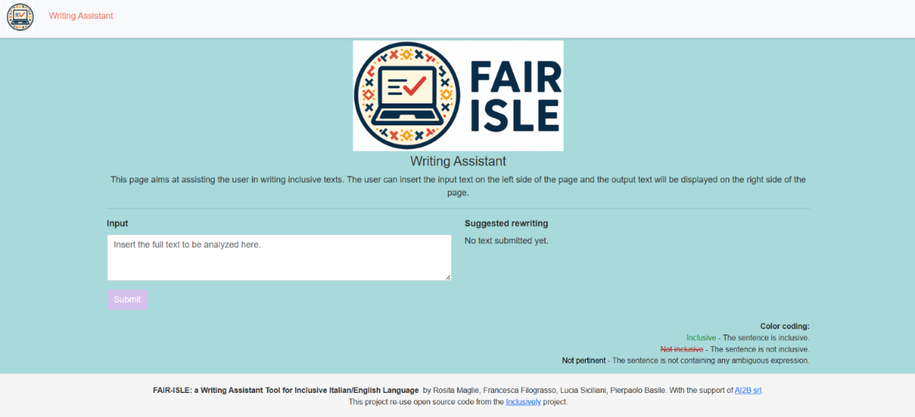

Il Redesign
With the maturation of the back-end, a complete rethink of the front-end became necessary to align the visual experience with the underlying technological quality. The redesign work “revolutionized” the application’s appearance, introducing a modern, clean, and professional graphic language.
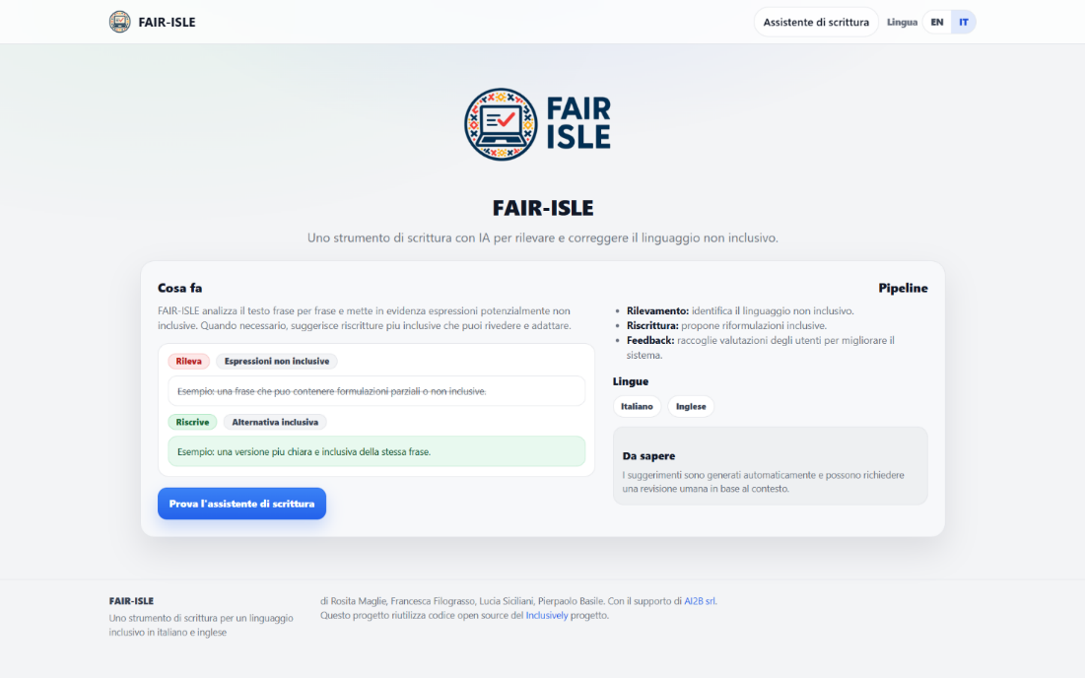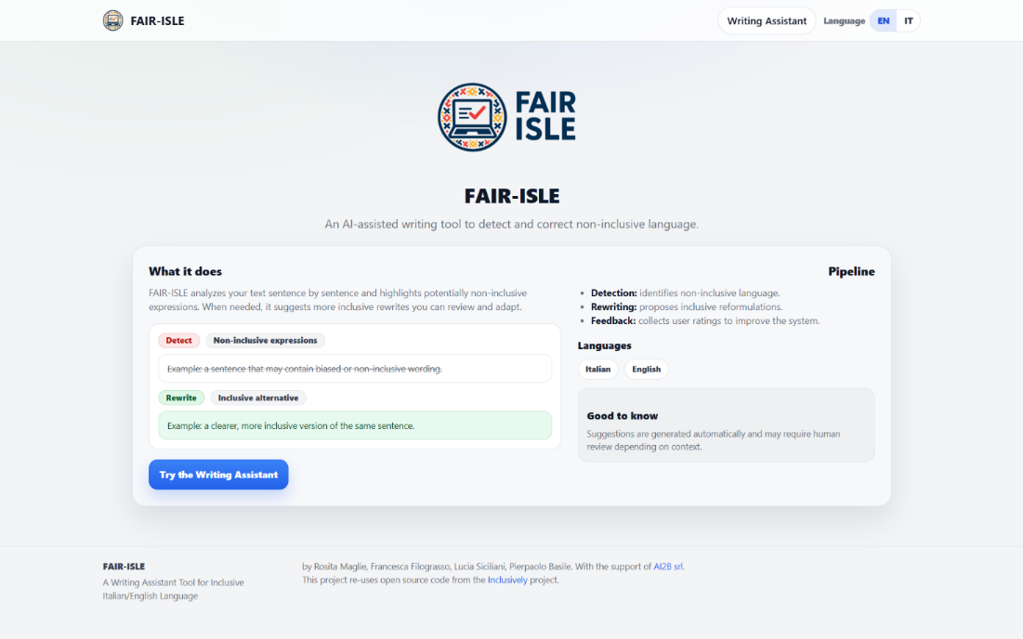

Active Feedback Loop
The UI introduces a double evaluation channel that turns the user into an active validator:
- Confirmation or denial of classification (reduction of false positives and false negatives).
- Evaluation of rewriting with the possibility to propose an alternative correction.
- Archiving of feedback in a JSON database for future retraining cycles.
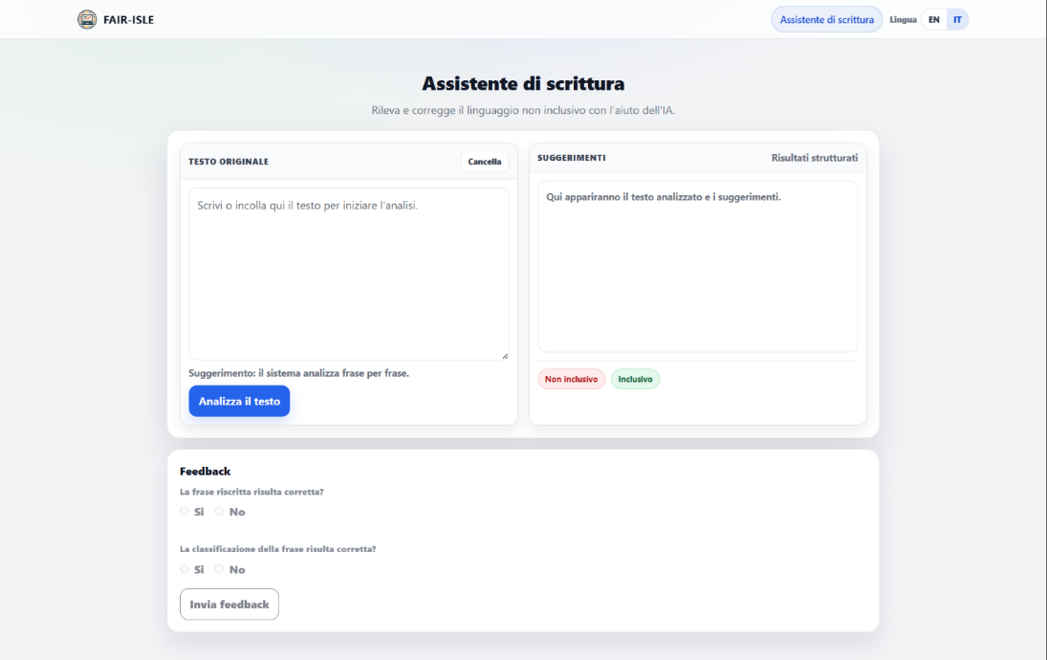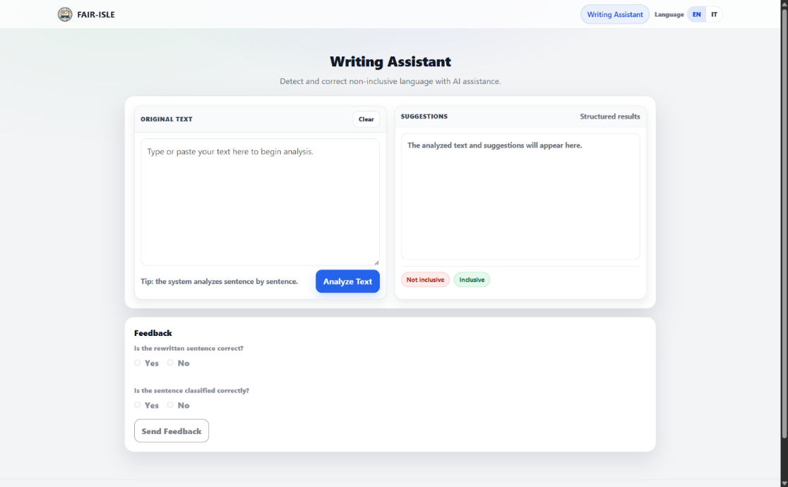

Essential references
- European Institute for Gender Equality (EIGE) - linee guida su linguaggio di genere.
- UN Women e Unione Europea - guide per comunicazione inclusiva.
- American Psychological Association (APA) - Bias-Free Language Guidelines.
- MIUR (2018) - Linee guida per l'uso del genere nel linguaggio amministrativo.
- UNI - linee guida per la parità di genere nel linguaggio.
- Hugging Face Transformers e modelli DistilBERT, BERTino, FLAN-T5, IT5, XLM-RoBERTa, mT5.



